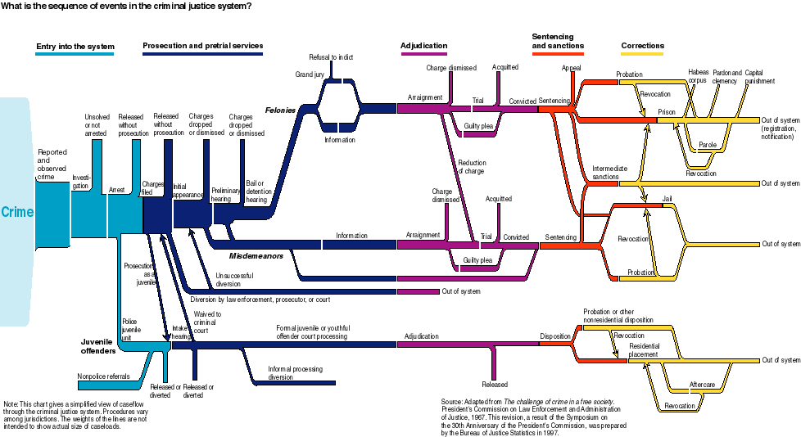
BJA Flowchart: http://bjs.ojp.usdoj.gov/content/largechart.cfm#
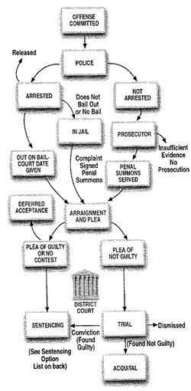
Honolulu, HI Misdemeanor: http://www1.honolulu.gov/prosecuting/flowchart.htm
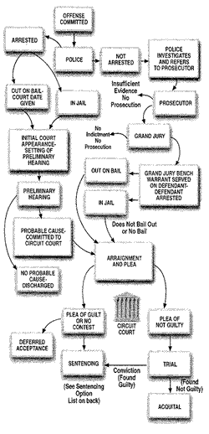
Honolulu, HI Felony: http://www1.honolulu.gov/prosecuting/flowchart.htm
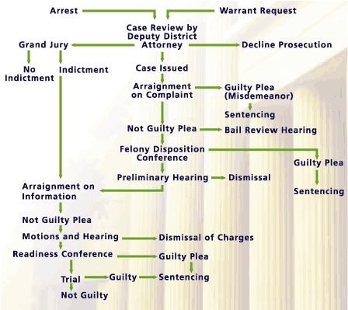
San Diego, CA: http://www.sdcda.org/office/criminal-justice-system.html

