How the ASAM Patient Placement Criteria Work
The ASAM Patient Placement Criteria provide separate placement criteria for adolescents and adults to create comprehensive and individualized treatment plans. Adolescent and adult treatment plans are developed through a multidimensional patient assessment over five broad levels of treatment that are based on the degree of direct medical management provided, the structure, safety and security provided, and the intensity of treatment services provided.
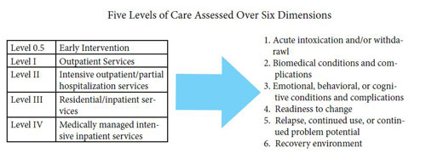
Through this strength-based multidimensional assessment the ASAM Patient Placement Criteria addresses the patient's needs, obstacles and liabilities, as well as the patient's strengths, assets, resources and support structures.

Oversight and Revision of the ASAM Patient Placement Criteria
Oversight and revision of the criteria is a collaborative process between ASAM leadership and the Steering Committee of the Coalition for National Clinical Criteria. The coalition represents major stakeholders in addiction treatment and has been meeting regularly since the development of the first ASAM Patients Placement Criteria in 1991. The coalition addresses feedback and ensures that the criteria adequately serves medical professionals, employers, purchasers, and providers of care in both the public and private sectors. (Full roster of members and their affiliations and minutes of meetings are available upon request). More...
http://www.asam.org/publications/the-asam-criteria

